**Project Design Phase-I**

**Proposed Solution**

|  |  |
| --- | --- |
| Date | 19 NOVEMBER 2022 |
| Team ID | PNT2022TMID47116 |
| Project Name | Project – Plasma Donor Application |
| Maximum Marks | 2 Marks |

**Proposed Solution – Plasma Donor Application**

# 1)

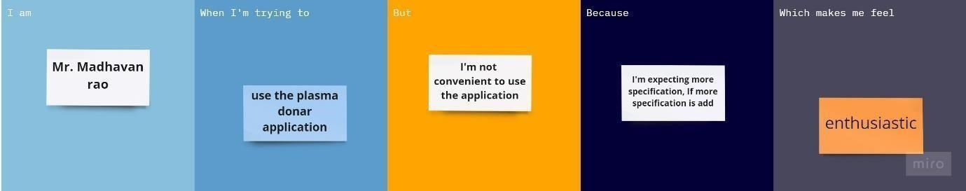

|  |  |  |
| --- | --- | --- |
| **S. No.** | **Parameter** | **Description** |
| 1. | Problem Statement (Problem to be solved) | I am Mr. Madhavan Rao when I’m trying to use the plasma donor application but I’m not convenient to use the application because I‘m expecting more specifications if more specifications are added, which makes me feel enthusiastic. |
| 2. | Idea / Solution description | The suggestion which is said by the user will be noted and the apt suggestions will be added |
| 3. | Novelty / Uniqueness | Everyone will have different ideas and different queries but the most important suggestions will be added to the application. |
| 4. | Social Impact / Customer Satisfaction | Almost Customers will be satisfied with the problem, and once again the problem occurs, it can be easily recovered. |
| 5. | Business Model (Revenue Model) | On a revenue base, this donor application will be profitable for hospitals, NGOs, and private organizations. |
| 6. | Scalability of the Solution | The problem of the donor was solved and also as per the user flexibility, the requirements can be modified. |

# 2)

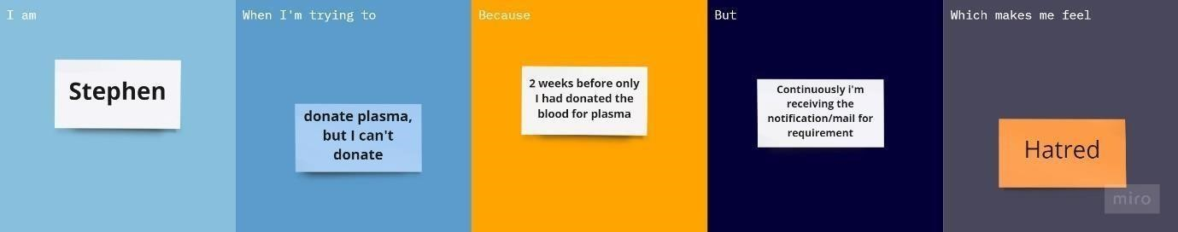

|  |  |  |
| --- | --- | --- |
| **S. No.** | **Parameter** | **Description** |
| 1. | Problem Statement (Problem to be solved) | I am Stephen when I’m trying to donate plasma,  But I can’t donate Because 2 weeks before only I had donated the blood for plasma, but continuously I’m receiving the notification/mail for requirement which makes me feel Hatred. |
| 2. | Idea / Solution description | Stephen needs to update his plasma donation details in the Application, if Still the issue occurs use “Contact Us” option in the application |
| 3. | Novelty / Uniqueness | This problem rarely occurs to the users/donar and not a common problem. It will be rectified from the “technical team”. |
| 4. | Social Impact / Customer Satisfaction | The Customer will be more satisfied with the solution and if once again the problem occurs, it can be easily recovered. |
| 5. | Business Model (Revenue Model) | On the revenue bases, this donar application will be profit for Hospital, NGO’s and private organizations. |
| 6. | Scalability of the Solution | The thought of the user/donar about the application will changed and also as per the user flexibility the requirements can be modified. |

# 3)

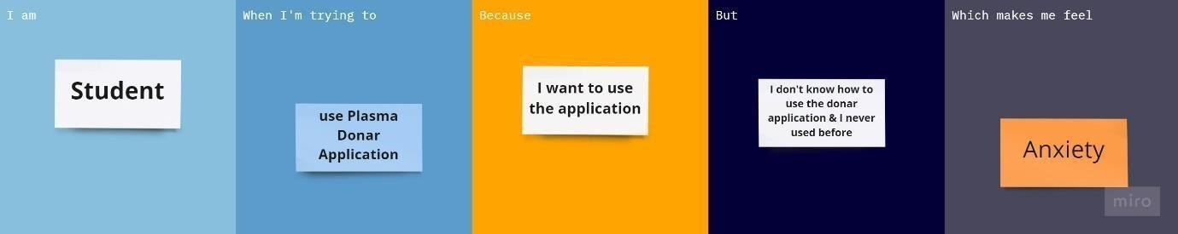

|  |  |  |
| --- | --- | --- |
| **S. No.** | **Parameter** | **Description** |
| 1. | Problem Statement (Problem to be solved) | I am a student I’m trying to use Plasma Donar Application Because I want to use the application, But I don’t how to use the donar application & I never used before which makes me feel Anxiety. |
| 2. | Idea / Solution description | The user should have basic knowledge about the application, read the user manual or else use the “Chat Bot” for the guidance to use the application efficiently. |
| 3. | Novelty / Uniqueness | It is common problem face by the new users who are trying to use the application. If the user once learns how to use, then there will be no issue. |
| 4. | Social Impact / Customer Satisfaction | The solution will be satisfied to the user. If any problem occurs once again it will be rectified. |
| 5. | Business Model (Revenue Model) | On the revenue bases, this donar application will be profit for Hospital, NGO’s and private organizations. |
| 6. | Scalability of the Solution | The problem of the donar was solved and also as per the user flexibility the requirements can be modified. |

# 4)

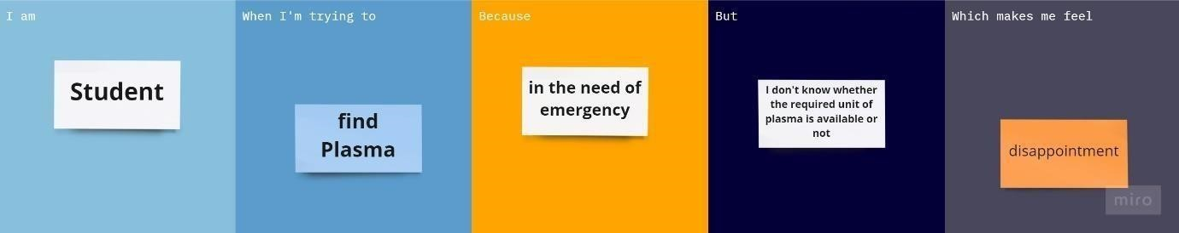

|  |  |  |
| --- | --- | --- |
| **S. No.** | **Parameter** | **Description** |
| 1. | Problem Statement (Problem to be solved) | I am a student I’m trying to find Plasma Because in the need of emergency, But I don’t whether the required unit of plasma is available or not which makes me feel disappointment. |
| 2. | Idea / Solution description | The user should know the required unit of plasma and then check the availability of plasma in the application. |
| 3. | Novelty / Uniqueness | It is not unique problem, these kind of problems faced by the new users or who don’t know to how use the application |
| 4. | Social Impact / Customer Satisfaction | The user will be more satisfied with the solution and there will be less chance of these kind of problem that repeat again. |
| 5. | Business Model (Revenue Model) | On the revenue bases, this donar application will be profit for Hospital, NGO’s and private organizations. |
| 6. | Scalability of the Solution | The mindset of the user about the application will changed and also as per the user flexibility the requirements can be modified. |

# Team ID : PNT2022TMID47116 Team Leader : MUTHULAKSHMI S Team member : DEEPIKA M Team member : KAVIPRIYA R Team member : SRILEKA R